Mth-4107 The Distance Formula
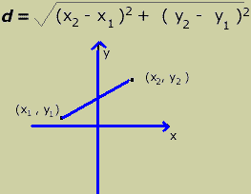
Derivation of the Distance Formula:
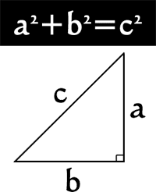

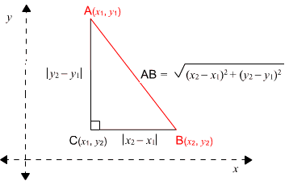
Examples:
This problem is done for you, as an example:

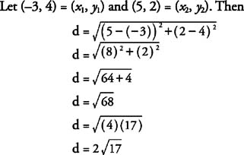

Now, let’s try some on our own!
1. Calculate the length of segment PQ.
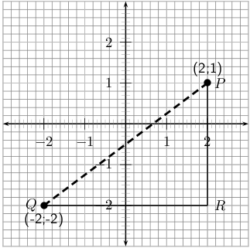

2. The structures on a family’s property are represented in the following Cartesian plane. Each structure corresponds to a given point.
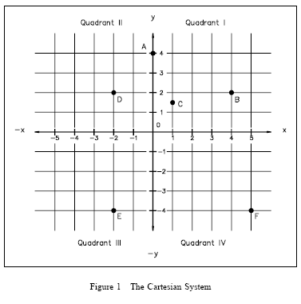Scale: 1 unit = 5m
a) Determine the coordinates of:
A: The gazebo: __________ D: The kids’ play fort: __________
B: The pool: __________ E: The hockey rink: __________
C: The main house: _________ F: The workshop: __________

b) For the following questions, round your answers to the nearest hundredth (two decimal places). Calculate the distance (in meters) between:
i) the pool and the rink

ii) the kids’ play fort and the workshop

iii) the hockey rink and the workshop

iv) the kids’ play fort and the rink

v) the pool and the kids’ play fort

vi) the gazebo and the main house

- Calculate the distance between each of the following pairs of points. Since there is no scale conversion given here, the unit, u will be used. Round your answers to the nearest tenth (one decimal place).

- ( 3, 4 ) and ( 6, 8)

- ( 9, -3) and ( -3, 2)

- ( -2.5, -7.3) and ( 5.2, 0)

- ( -7, 3) and ( -7, 12)

- ( 2, 4.3) and ( -5, 4.3)

- Calculate the perimeter of the following triangle. Use a scale of 1 unit = 1 cm.
Round your answer to the nearest hundredth.

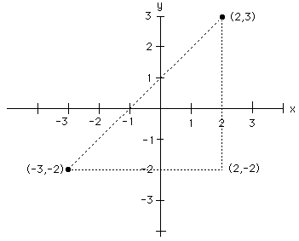

- Calculate the perimeter of the following polygon. Use a scale of 1 unit = 1 cm.
Round your answer to the nearest tenth.
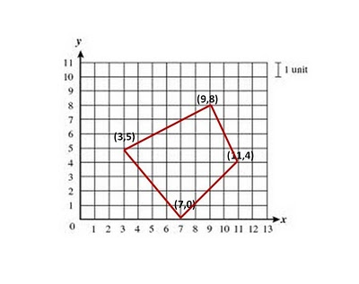

- The cartesian plane below depicts the path and distances involved in a motorbike race. The bikers start at P1 and continue on through P2, P3, P4, P5, and then back to P1. Given that each unit corresponds to 7km, what is the total distance of the race? Round your answer to the nearest hundredth.
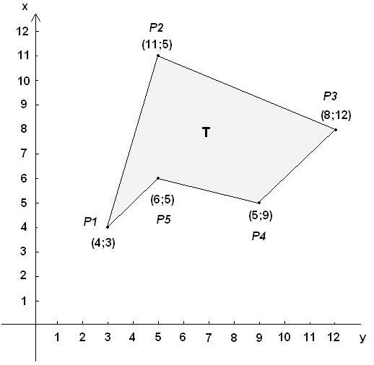

7.

8.

9.

