Name:__________ Date:______________

1)

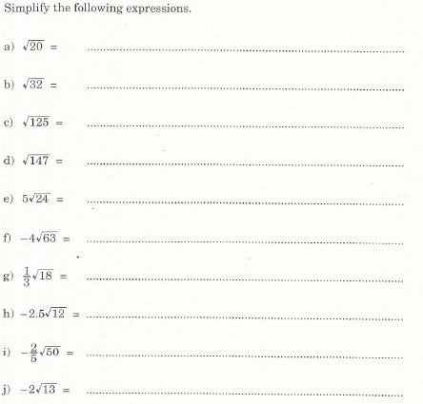

2)

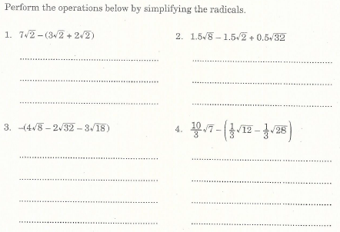

3)

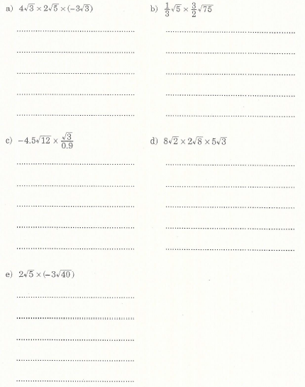

4)

