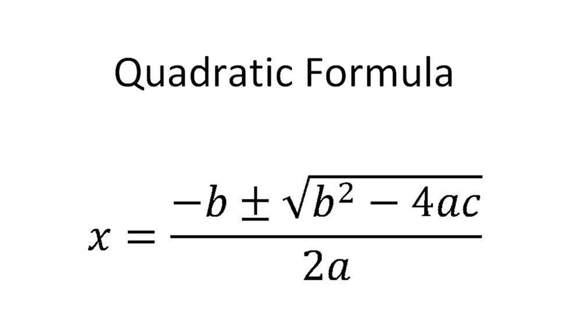
Solve the following equations using the quadratic formula:
- -x² + 4x = 4

- 3x² – 6x = 0

- $\frac{1}{2}$ x² + x + $\frac{7}{2}$ = 0

- $\frac{1}{2}$ x² – 2x + 4 = 0

- -x² + 10x = 16

- 2x² + 2x - $\frac{9}{2}$ = 0

- -x² + 6x = 9

- -9x² + 6x – 1 = 0

- 3x² – 12 = 0

- 3x + 4 = x²

