Worksheet #3 Practice Isolating “y”
Important Points:
- “y” must be alone (isolated) so that the equation is in the form y=mx + b in order for the slope and y-intercept to be “visible”.
- The slope (m) is the number in front of x. Do not include an “x” as part of the slope. E.g. y = 4x – 2 … slope= m= 4 (NOT 4x)
- The y-intercept is the “b”. This is the point on the y-axis where the line would cross. E.g. y = 2x +1 … y-intercept= b= 1 (see below)

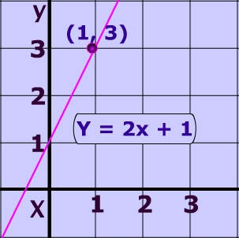

So, we need to practice isolating the “y” in various equations…

slope (m) and the y-intercept (b).

- 2x + 5y = 10

- $\frac{1}{2}$ x + 2y = 4

- 6x – 3y – 3 = 0

- x – 4y = 0

- $\frac{1}{4}$ x + $\frac{1}{2}$ y – 2 = 0

- 3x + $\frac{2}{3}$ y = 5

- $\frac{x}{4}$ + $\frac{y}{3}$ = $\frac{1}{2}$
- -2x - $\frac{y}{2}$ = $\frac{2}{3}$

- $\frac{1}{5}$ x – 2 = $\frac{4}{5}$ y

- $\frac{-x}{3}$ = $\frac{-y}{2}$ + $\frac{1}{4}$

- 6x

